**FINAL CAUTION AND EXPULSION CHART IN 2023/2024 NPFL SEASON**

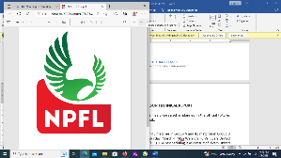

|  |  |  |  |
| --- | --- | --- | --- |
| **S/N** | **Name Of Clubs** | **Caution** | **Expulsion** |
| 1 | Remo Stars FC | 92 | 7 |
| 2 | Enyimba Int’l FC | 84 | 6 |
| 3 | Bayelsa United FC | 82 | 5 |
| 4 | Kano Pillars FC | 74 | 5 |
| 5 | Sunshine Stars FC | 68 | 4 |
| 6 | Gombe United FC | 81 | 3 |
| 7 | Katsina United FC | 80 | 3 |
| 8 | Shooting Stars SC | 71 | 3 |
| 9 | Plateau United FC | 62 | 3 |
| 10 | Sporting Lagos FC | 81 | 2 |
| 11 | Rivers United FC | 78 | 2 |
| 12 | Abia Warriors FC | 51 | 2 |
| 13 | Heartland FC | 81 | 1 |
| 14 | Lobi Stars FC | 67 | 1 |
| 15 | Kwara United FC | 66 | 1 |
| 16 | Akwa United FC | 55 | 1 |
| 17 | Bendel Insurance FC | 70 | 0 |
| 18 | Doma United FC | 68 | 0 |
| 19 | Niger Tornadoes FC | 55 | 0 |
| 20 | Rangers Int’l FC | 55 | 0 |
| **Grand Total** | | **1,421** | **49** |